
ANNOUNCING
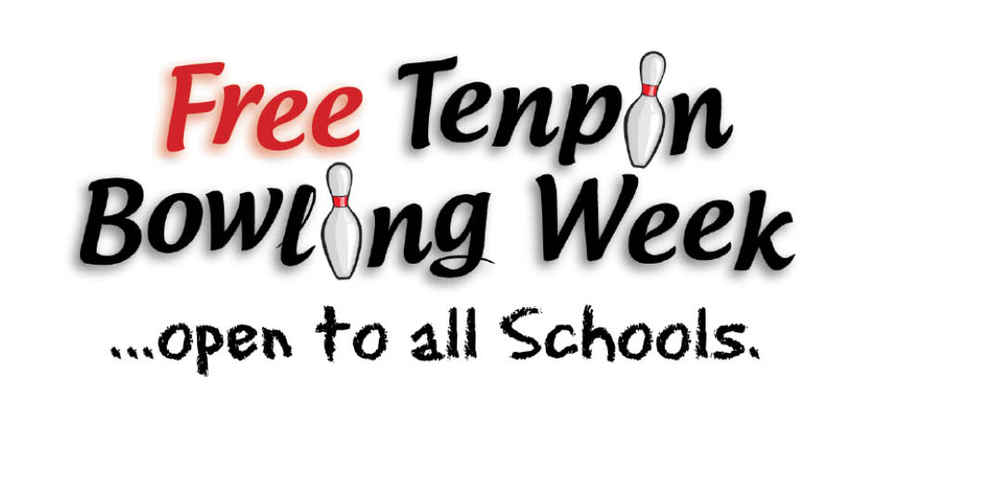

Full details on
www.bowlingforall.ie

NOVEMBER 9th to 13th 2015

Following on from the phenomenal success of last year’s initiative where 19,300 school goers, in over 350 schools, availed of FREE Tenpin Bowling, 30 bowling centres countrywide have joined together to offer a similar giveaway this year.
Last year’s secondary schools winners, St Kieran’s College, Kilkenny and national schools winners, St Patrick’s, Sion, Crossabag, Wexford will we hope, be looking to retain their respective titles. All national and secondary schools are invited to contact their local participating centre and secure the deal. It could not be any simpler.
For further information contact: ABCDEFGHI Bowl
Add Contact 1 – 08x xxx xxxx
Add Contact 2 – 08x xxx xxxx
E’mail: info@xxxxxxyyyyyy.ie

Proudly Sponsored by
Supported by

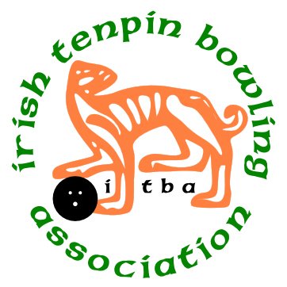
Supported by

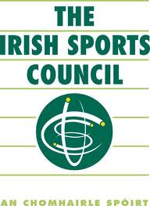

www.mediascene.ie
www.irishsportscouncil.ie
www.tenpinbowling.ie

